New Urban Policy Council chairperson Kalland: Our education system is not as equal as we think – family has larger impact than grades

Press release – EMBARGO UNTIL 22 January 2025 at 11 am.
The new Urban Policy Council is an autonomous and independent research panel that produces a critical report of a chosen urban policy theme every year. Its first report, published today, is about education and learning, with a particular focus on the segregation of learning and well-being in early childhood.
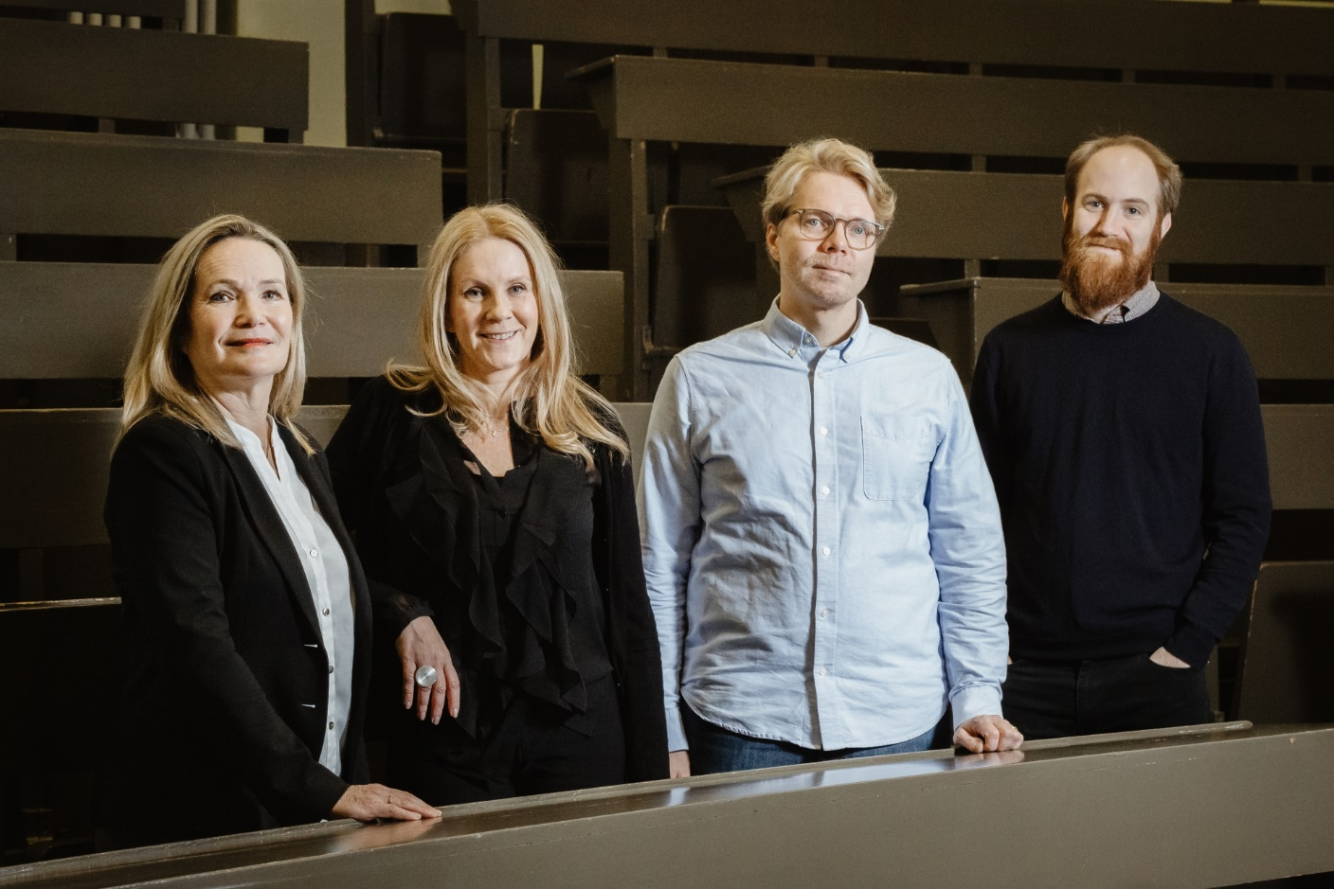
The Urban Policy Council members Mirjam Kalland, Raisa Ahtiainen, Matti Sarvimäki and Mikko Silliman. Photo: Salla Merikukka.
The Urban Policy Council is a new cooperation body that is financed by the cities of Espoo, Helsinki and Vantaa as well as Aalto University and the University of Helsinki. The council operates independently of its financiers.
- I am happy to see that the Finnish Economic Policy Council has taken a significant role as a commentator of national economic policy. We have wanted a similar independent body for the cities of the Helsinki Metropolitan Region from Finland’s best researchers in the field. The new council introduces to us the latest research on the impact of decisions. I believe their report will help us improve learning outcomes and solve the equality challenges in education.
- Juhana Vartiainen, Mayor of Helsinki
After the health and social services reform in particular, education is one of the most significant responsibilities that municipalities have. Helsinki, Espoo and Vantaa have a combined education budget of three billion euros in 2025. Many of the more significant difficulties in municipal decision-making are in education.
That is why the first members of the council are four highly respected educational sciences and education economics researchers from Aalto University and the University of Helsinki.
The council chairperson will be Mirjam Kalland (PhD, Educational Sciences) from the University of Helsinki, and its vice-chair will be Matti Sarvimäki (PhD, Economics) from Aalto University. The other council members are Raisa Ahtiainen (PhD, Educational Sciences) from the University Helsinki and Mikko Silliman (PhD) from Aalto University.

First council report focuses on education and learning
School segregation, gender differences in learning outcomes, the general fall in learning outcomes and immigration make it difficult for municipalities to make decisions on education. The Basic Education Act requires the provision of equal, nationwide education. The Council’s report states that there is currently not enough data on whether this requirement is being fulfilled. For these reasons, the Council has decided to focus on the segregation of learning and well-being during childhood.
- Pupil backgrounds impact both their success at school and their placement in further education and the job market. For example, differences in learning between children with an immigrant background and other children are significantly large in Finland on the international level. Studies also show that the children of parents with similarly low grades do not seek further education as much as the children of parents with a background in higher education. Our education system is not as equal as we think.
- Mirjam Kalland, chairperson of the Urban Policy Council
A significant number of the key decisions for the education system are made in the cities. Individual schools have a particularly large impact. Therefore, the council wants more data and understanding on how schools and teachers succeed in their most important task.
- Schools make significant decisions for children every single day. This also generates a great deal of data of their learners. Unfortunately, this data is not sufficiently used in either research or decision-making. Furthermore, there are some key pieces of data that are currently not collected at all. We see that the council has an opportunity to boost the role of research data in the planning of educational policy and to create new materials for researchers and decision-makers to use.
- Matti Sarvimäki, vice-chair of the Urban Policy Council.
One of the most important questions of today is the efficient and fair allocation of resources. For example, added funding for schools in the most difficult environments could improve their learning outcomes and educational equality. There is, however, a need for further data on how this type of needs-based funding should be implemented to achieve the desired results. The council intends to focus particularly on the distribution of resources and assess to what degree the allocation thereof is based on knowledge. It aims to publish its first report in late 2025.

Council members
Mirjam Kalland
The chairperson, Mirjam Kalland, has a PhD in educational sciences and is the professor of early childhood education at the University of Helsinki. Kalland is a respected researcher, who studies methods to boost children’s socio-emotional and linguistic development in early childhood education from a multi-language perspective. She is the chairperson of the Mannerheim League for Child Welfare. Kalland is internationally renowned and has been a researcher with an ASLA-Fulbright grant at Yale University’s Child Study Center.
Matti Sarvimäki
Vice-chair Matti Sarvimäki is an associate professor of economics at Aalto University’s School of Business and a senior researcher at VATT Institute for Economic Research. Sarvimäki has studied the impact of integration measures and educational interventions, immigration and social mobility, among other things. He has also held a post as a research at the London School of Economics and as a visiting fellow at the Massachusetts Institute of Technology. Sarvimäki is the vice-chair of the Academy of Finland’s EDUCA Flagship project.
Raisa Ahtiainen
Member of the council, docent Raisa Ahtiainen has a PhD in educational sciences and works as a university lecturer at the University of Helsinki’s Faculty of Educational Sciences. Ahtiainen is the executive director of the Leadership in Educational Contexts research group (KAJO). Additionally, she is a principal investigator at the University of Helsinki’s Centre for Educational Assessment CEA. In addition to leadership, Ahtiainen studies school development, social justice questions in education and cooperation in school communities. In 2022, Ahtiainen became the first Swedish-language university lecturer in special pedagogics. Ahtiainen has an extensive international network and she is a visiting fellow for leadership in education at the University of Tallinn.
Mikko Silliman
Member of the council, Mikko Silliman has a PhD and is an assistant professor at the Aalto University Department of Economics. Silliman focuses on the interface between educational policy and the labour market in his research. Silliman is a member of various international research networks, such as Helsinki GSE and the Norwegian School of Economics NHH’s FAIR Centre. He completed his dissertation at Harvard University.

The unveiling event of the Council’s research theme on Wednesday, 22 January also included a discussion consisting of Acting Mayor of Espoo Olli Isotalo, Mayor Juhana Vartiainen and Deputy Mayor of the Education Division Johanna Laisaari from Helsinki and Mayor Pekka Timonen and Deputy Mayor Katri Kalske from Vantaa.

Urban Policy Council
The Urban Policy Council is an independent academic actor. It is financed by the cities of the Helsinki Metropolitan Region, Espoo, Helsinki and Vantaa, in cooperation with Aalto University and the University of Helsinki. The secretary general of the council is Jari Järvenpää.

Additional information
Mirjam Kalland
Chairperson of the Urban Policy Council
+358 29 412 8401
mirjam.kallad@helsinki.fi

Jari Järvenpää
Secretary general of the Urban Policy Council
+358 40 355 7304
jari.p.jarvenpaa@hel.fi

https://kaupunkiarviointi.fi

